

Mathematics Specialist Unit 2

Test 5

Trigonometric Identities and proof

Name: ______________________ Total Marks:__________

Task type: Response

Time allowed for this task: 60 minutes, in-class, under test conditions
Section One: Calculator-free 38 minutes ( 34 marks)
(3 Minutes Reading – 35 Minutes Working)
Section Two: Calculator-assumed 22 minutes ( 22 marks)
(2 minutes Reading - 22 minutes working)

Materials required: Calculator with CAS capability (to be provided by the student)

Standard items: Pens (blue/black preferred), pencils (including coloured), sharpener, correction fluid/tape, eraser, ruler, highlighters

Special items: Drawing instruments, templates, notes on one unfolded sheet of
A4 paper, and up to three calculators approved for use in the WACE examinations
Formula sheet

Marks available: 56 marks

Task weighting: 7%

Section One : Calculator Free 35 Marks
Time Allowed 30 minutes

Question 1 (9 marks)

- Express $\sqrt{3}\sin{x}+\cos{x}$ in the form $R\sin{(x+α)}$ where $0≤α≤\frac{π}{2}$

- Hence, or otherwise solve $\sqrt{3}\sin{x}+\cos{x}=1$, for $0≤x≤2π$

- Sketch the graph $y=\sqrt{3}\sin{x}+\cos{x}$ on the grid below.

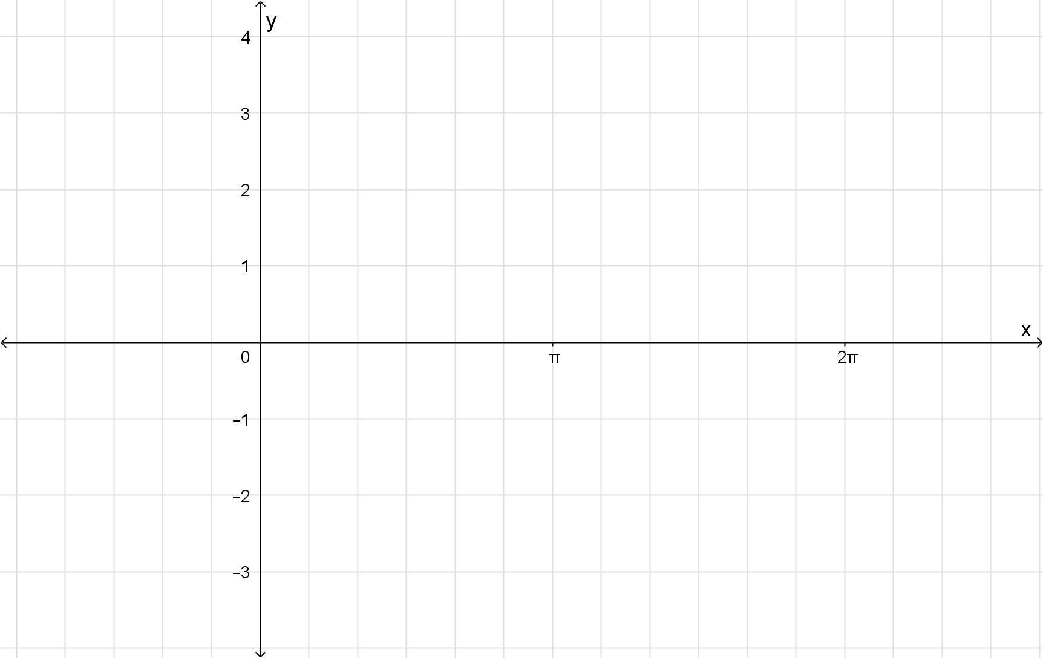

Question 2 (3 marks)

Express $cos75°cos15°$ in exact form

Question 3 (8 marks)

- Prove $\cos\left(3A\right)=4\cos^{3}A-3\cos{A}$
(5 marks)

- Solve ${8cos}^{3}A=6\cos{A}+1$ for $0≤A≤π$
(3 marks)

Question 4 (5 marks)

Find all the solutions to the equation
$$cos(2x)+7sinx=4$$

Question 5 (5 marks)

Prove by contradiction that $\log_{2}{7}$ is irrational.

Question 6 (5 marks)

Prove using mathematical Induction for all $n≥1$.

Section Two : Calculator Assumed 22 Marks
Time Allowed 30 minutes Name:_______________________

Question 7
(6 marks)

- Show that $2.7\overline{12}$ is a rational number.
(2 marks)

- Use algebraic reasoning to prove that the sum of the squares of two consecutive integers is odd.
(4 marks)

Question 8 (4 marks)

Prove that

Question 9
(5 marks)
Prove using mathematical induction that $2^{n+2}+3^{3n}$ is divisible by 5 for $n∈N$.

Question 10 (7 marks)

Prove the following identities

- ${cosec}^{2}x \tan^{2}x-1=\tan^{2}x$

- $\operatorname{cosec}{2x}+\cot{2x=\cot{x}}$

